**VDDK Image Build and Push for SNO OCP – Internal image-registry**

Objective:

Build a VDDK container image and push it to the internal OpenShift registry (SNO setup) for use in MTV (Migration Toolkit for Virtualization).

Steps:

1. In a browser, navigate to the [VMware VDDK version 8 download page](https://developer.vmware.com/web/sdk/8.0/vddk).
2. Select version 8.0.1 and click Download.
3. Save the VDDK archive file in the temporary directory.
4. Extract the VDDK archive: in a temporary directory.

1. Extracted VDDK tarball:

- Unzipped the provided `vddk` tar file on the SNO node.

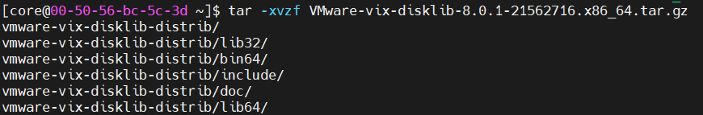

2. Identified internal OpenShift registry service:

- Verified using:

oc get service image-registry -n openshift-image-registry



3. Logged in to internal registry from SNO node:

podman login --tls-verify=false -u kubeadmin -p $(oc whoami -t) image-registry.openshift-image-registry.svc:5000



4. Built the VDDK image using podman:

podman build -t image-registry.openshift-image-registry.svc:5000/mtv/vddk:latest .

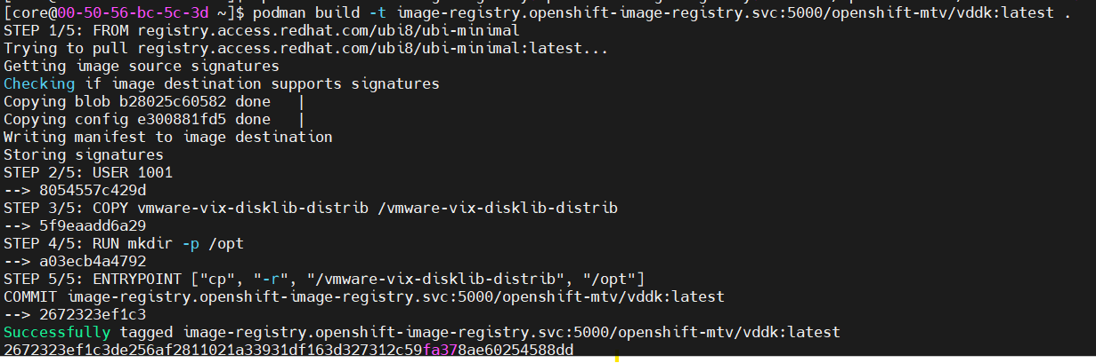

5. Pushed the image to OpenShift internal registry:

podman push --tls-verify=false image-registry.openshift-image-registry.svc:5000/mtv/vddk:latest

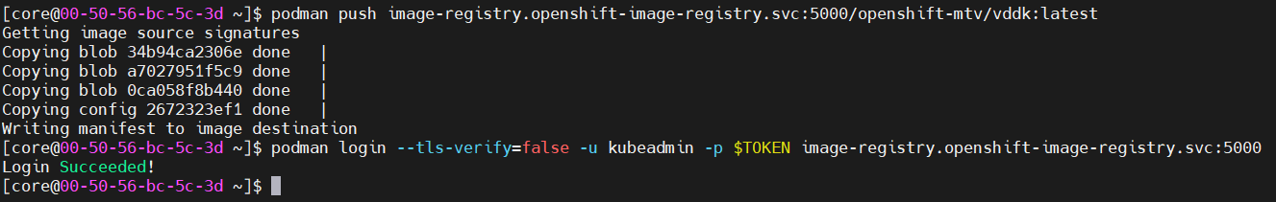

6. Configured the image path in MTV GUI:

- Used:

image-registry.openshift-image-registry.svc:5000/mtv/vddk:latest

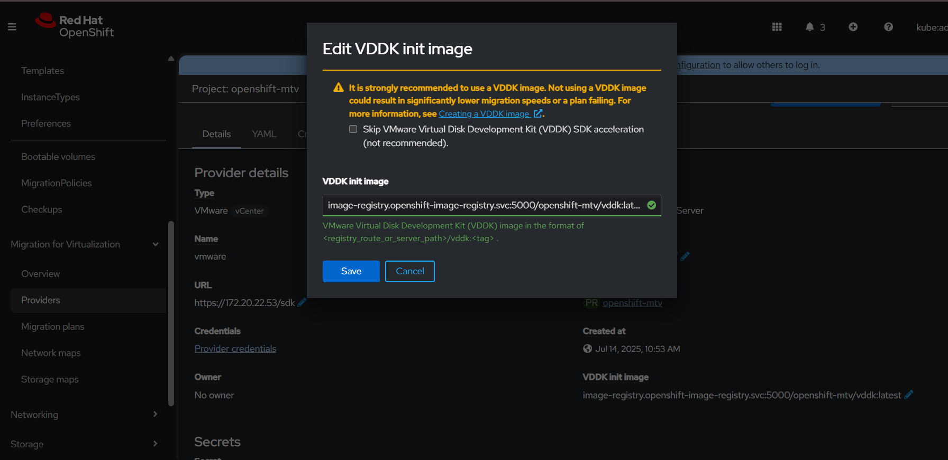

Notes:

1. DNS Resolution Failure from Bastion:

- Error: no such host

- Cause: Bastion node could not resolve internal service DNS (not part of cluster network).

- Fix: Switched to running all steps directly on the SNO node.

2. Missing token for oc whoami -t:

- On SNO node, no valid kubeconfig was present under core user.

- Fix: Used manual token login or ensured kubeconfig availability.

3. Hanging podman login from Bastion:

- Reason: Could not reach the registry service from outside the cluster.

- Fix: Ran podman login from within the SNO node.

✅ Final VDDK Image Path Used:

image-registry.openshift-image-registry.svc:5000/mtv/vddk:latest